Work Break-down Structure (Process Based, Product Based, Geographic Based and Role Based) and Estimations
Aim:
To develop a comprehensive Work Breakdown Structure (WBS) to systematically decompose project tasks and enhance project management efficiency. Utilize accurate estimations to provide realistic timelines and resource allocations for each WBS component, ensuring successful project planning and execution.
Procedure:
A Work Breakdown Structure includes dividing a large and complex project into simpler, manageable, and independent tasks. The root of this tree (structure) is labeled by the Project name itself. For constructing a work breakdown structure, each node is recursively decomposed into smaller sub-activities, until at the leaf level, the activities become undividable and independent. It follows a Top-Down approach.
Step-by-step guide to create a Work Breakdown Structure

Step 1: Define the Project Scope
The first step in creating a WBS is to define the project scope. This involves identifying the project's purpose, stakeholders, and desired outcomes. The project's scope will determine the WBS's overall structure and the specific tasks and activities that must be included.

Step 2: Identify Deliverables
The next step is to identify the deliverables of the project. These are the tangible or intangible products or services that will be produced as a result of the project. Deliverables may include legal documents, research reports, client memos, or other outputs. Identifying these deliverables will help to create a framework for the project and ensure that all necessary tasks and activities are included in the WBS.

Step 3: Break Down Deliverables into Sub-Deliverables
Once the deliverables have been identified, they should be broken down into sub-deliverables. These are smaller components that make up the overall deliverables. For example, a legal document may be broken down into sections, each with its requirements. Breaking down deliverables into sub-deliverables will help identify the specific tasks and activities that must be completed to achieve each sub-deliverable.
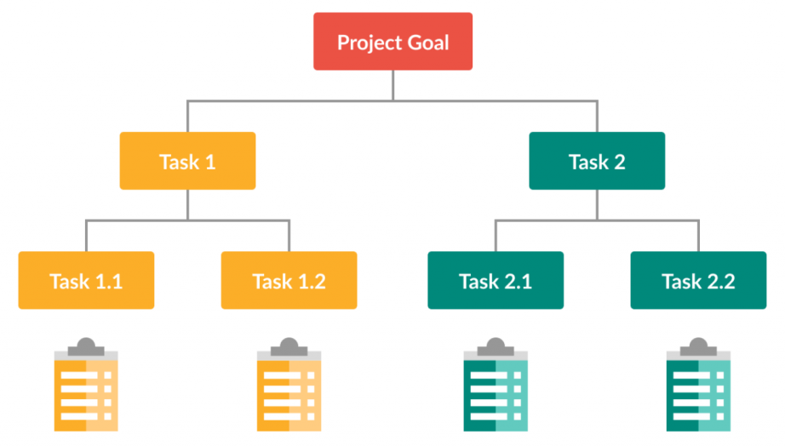

Step 4: Identify Tasks and Activities
With the sub-deliverables identified, the next step is identifying the tasks and activities needed to achieve them. This involves breaking down each sub-deliverable into specific tasks and activities that must be completed to achieve it. For example, tasks may include research, drafting, editing, and reviewing for a legal document section. Identifying tasks and activities will help to ensure that all necessary work is accounted for in the WBS.

Step 5: Assign Responsibility
Once the tasks and activities have been identified, they should be assigned to specific team members or stakeholders. This involves determining who will be responsible for completing each task or activity. Assigning responsibility will ensure that each task is completed efficiently and that there is no duplication of effort.

Step 6: Estimate Time and Resources
With the tasks and activities identified and assigned, the next step is to estimate the time and resources needed to complete each task. This involves estimating the time to complete each task and identifying the required resources, such as personnel, equipment, and materials. Estimating time and resources will help ensure the project is completed on time and within budget.

Step 7: Create a WBS Diagram
The final step is to create a WBS diagram. This visual representation of the WBS shows the hierarchy of deliverables, sub-deliverables, tasks, and activities. The WBS diagram clearly shows the relationships between each component and provides a roadmap for the project. It should also include the estimated time and resources needed for each task.

Process-Based Work Breakdown Structure
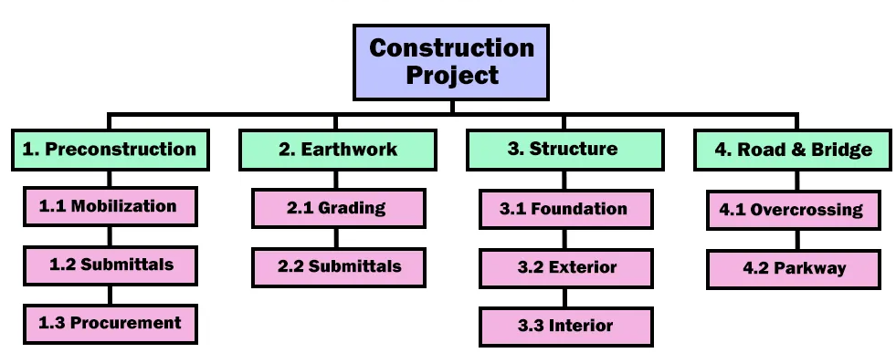
A process-based WBS divides the project into different phases. A process-based WBS has the project or deliverables at the top, with different layers that break the project into phases of work. Some phases may include Pre-construction, Construction, and Project Completion. Phases can be broken down into sub-phases to create a hierarchical outline of the work that needs to be completed.

Product Breakdown Structure

A Product Breakdown Structure (PBS) is a communication tool used in project management to systematically break down complicated projects or product developments into smaller, conceivable components and responsibilities. This hierarchical illustration helps understand, plan, and organize the work scope required for successful project execution. The PBS complements communication, helps allocation, and general project management performance by imparting a clear roadmap of the project's structure.
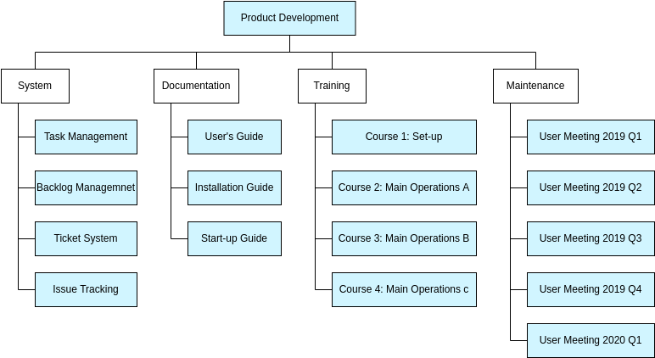

Work breakdown structure example for software development
A new e-commerce site must be executed impeccably and clearly, since there are so many competitors on the market.
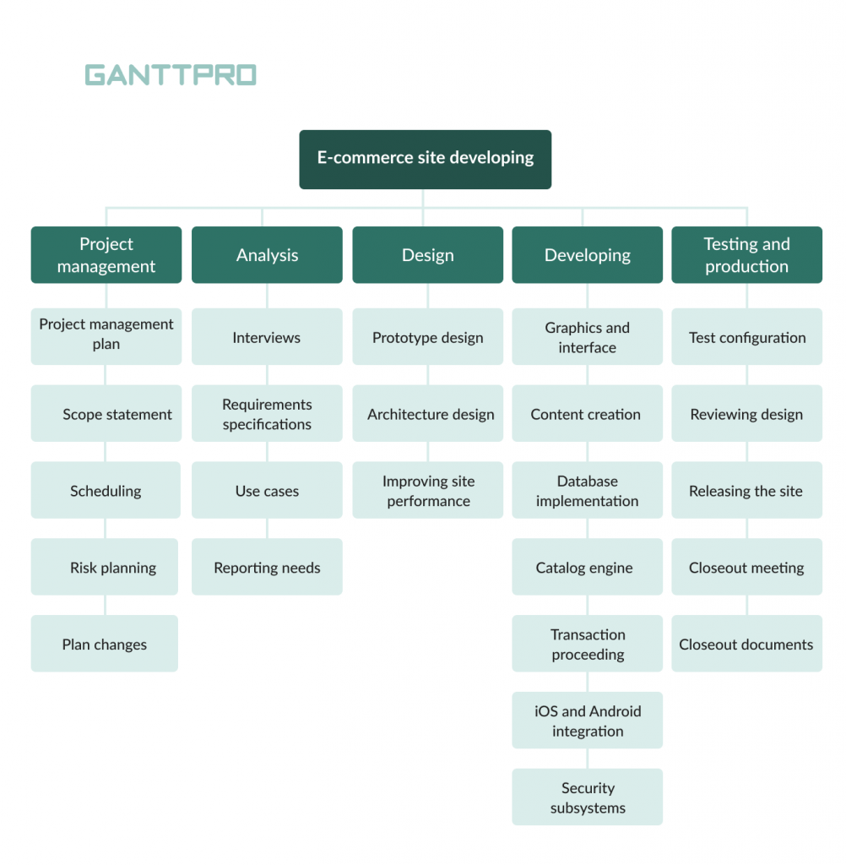

The result-oriented tree work breakdown structure of a software project focuses on the project management, analysis, designing, developing, and testing stages.

- Project management. The first stage of our work breakdown structure for software project example includes planning, defining scope, scheduling, risk management, and work with possible plan changes.

- Analysis. At this stage, project teams conduct required interviews, work on requirements specifications, and prepare use cases.

- Design is one of the most essential parts of our software development work breakdown structure example. Here, you should care about the prototype design, architecture design, and site performance improvements.

- Developing. This is typically one of the most active phases of software development, so you will need to thoroughly work on developing the new e-commerce site and care about all the details, meaning graphics and interface, content creation, database implementation, catalog engine, transaction processing, iOS and Android integration, security, and other important issues.

- Testing and production are what end the process. This is when test configuration, reviewing design, releasing the site, closeout meetings, and preparing closeout documents happen.

The work breakdown structure WBS in project management for software development needs is pretty clear and simple to be implemented with the help of a Gantt chart.
